UNIT2 : JAVA PROGRAMS

TASK1
You are given a string s of even length. Split this string into two halves of equal lengths, and let a be the first half and b be the second half.
Two strings are alike if they have the same number of vowels ('a', 'e', 'i', 'o', 'u', 'A', 'E', 'I', 'O', 'U'). Notice that s contains uppercase and lowercase letters.
Return true if a and b are alike. Otherwise, return false.

Example 1:
Input: s = "book"
Output: true
Explanation: a = "bo" and b = "ok". a has 1 vowel and b has 1 vowel. Therefore, they are alike.
Example 2:
Input: s = "textbook"
Output: false
Explanation: a = "text" and b = "book". a has 1 vowel whereas b has 2. Therefore, they are not alike.
Notice that the vowel o is counted twice.
PROGRAM:
class Solution {
public boolean halvesAreAlike(String s) {
String vowels = "aeiouAEIOU";
int mid = s.length() / 2;
int count = 0;

for (int i = 0; i < mid; i++) {
if (vowels.indexOf(s.charAt(i)) != -1) {
count++;
}
if (vowels.indexOf(s.charAt(i + mid)) != -1) {
count--;
}
}

return count == 0;
}
}
OUTPUT:
"book"
Output
true
Expected
True

TASK2
Lapindrome is defined as a string which when split in the middle, gives two halves having the same characters and same frequency of each character. If there are odd number of characters in the string, we ignore the middle character and check for lapindrome. For example gaga is a lapindrome, since the two halves ga and ga have the same characters with same frequency. Also, abccab, rotor and xyzxy are a few examples of lapindromes. Note that abbaab is NOT a lapindrome. The two halves contain the same characters but their frequencies do not match.
Your task is simple. Given a string, you need to tell if it is a lapindrome.
Input:
First line of input contains a single integer T, the number of test cases.
Each test is a single line containing a string S composed of only lowercase English alphabet.
Output:
For each test case, output on a separate line: "YES" if the string is a lapindrome and "NO" if it is not.
Constraints:
- 1 ≤ T ≤ 100
- 2 ≤ |S| ≤ 1000, where |S| denotes the length of S
PROGRAM:
import java.util.*;

class Solution {
public static void main(String[] args) {
Scanner sc = new Scanner(System.in);
int T = sc.nextInt();

while (T-- > 0) {
String s = sc.next();

int n = s.length();
String first, second;

if (n % 2 == 0) {
first = s.substring(0, n / 2);
second = s.substring(n / 2);
} else {
first = s.substring(0, n / 2);
second = s.substring(n / 2 + 1);
}

if (isLapindrome(first, second)) {
System.out.println("YES");
} else {
System.out.println("NO");
}
}
}

static boolean isLapindrome(String a, String b) {
int[] count = new int[26]
for (char c : a.toCharArray()) {
count[c - 'a']++;
}
for (char c : b.toCharArray()) {
count[c - 'a']--;
}

for (int i : count) {
if (i != 0) return false;
}

return true;
}
}

OUTPUT:
Sample Input sample output
Gaga YES
Abcde NO
Rotor YES
Xyzxy YES
Abbaab NO
Ababc NO

TASK3
Given an integer array nums, return true if any value appears at least twice in the array, and return false if every element is distinct.

Example 1:
Input: nums = [1,2,3,1]
Output: true
Explanation:
The element 1 occurs at the indices 0 and 3.
Example 2:
Input: nums = [1,2,3,4]
Output: false
Explanation:
All elements are distinct.
Example 3:
Input: nums = [1,1,1,3,3,4,3,2,4,2]
Output: true
PROGRAM:
import java.util.*;

class Solution {
public boolean containsDuplicate(int[] nums) {
HashSet<Integer> set = new HashSet<>();

for (int num : nums) {
if (set.contains(num)) {
return true; // duplicate found
}
set.add(num);
}

return false; // no duplicates
}
}

OUTPUT:
Input
nums =
[1,2,3,1]
Output
true
Expected
True

TASK4
Given an integer array nums, return true if any value appears at least twice in the array, and return false if every element is distinct.

Example 1:
Input: nums = [1,2,3,1]
Output: true
Explanation:
The element 1 occurs at the indices 0 and 3.
Example 2:
Input: nums = [1,2,3,4]
Output: false
Explanation:
All elements are distinct.
Example 3:
Input: nums = [1,1,1,3,3,4,3,2,4,2]
Output: true

PROGRAM:
import java.util.*;

class Solution {
public boolean containsDuplicate(int[] nums) {
HashSet<Integer> set = new HashSet<>();

for (int num : nums) {
if (set.contains(num)) {
return true; // duplicate found
}
set.add(num);
}

return false; // all elements unique
}
}

OUTPUT:
Input
nums =
[1,2,3,1]
Output
true
Expected
True

TASK5
Given a time in -hour AM/PM format, convert it to military (24-hour) time.
Note: - 12:00:00AM on a 12-hour clock is 00:00:00 on a 24-hour clock.
- 12:00:00PM on a 12-hour clock is 12:00:00 on a 24-hour clock.
Example
- Return '12:01:00'.
- Return '00:01:00'.
Function Description
Complete the function with the following parameter(s):
- : a time in hour format
Returns
- : the time in hour format
Input Format
A single string that represents a time in -hour clock format (i.e.: or ).
Constraints
- All input times are valid
Sample Input 0
07:05:45PM
Sample Output 0
19:05:45
PROGRAM:
import java.util.*;

class Solution {

public static String timeConversion(String s) {
String period = s.substring(8); // AM or PM
int hour = Integer.parseInt(s.substring(0, 2));
String rest = s.substring(2, 8); // :mm:ss

if (period.equals("AM")) {
if (hour == 12) {
return "00" + rest;
} else {
return String.format("%02d", hour) + rest;
}
} else { // PM
if (hour != 12) {
hour += 12;
}
return hour + rest;
}
}

public static void main(String[] args) {
Scanner sc = new Scanner(System.in);
String s = sc.next(); // input time

String result = timeConversion(s);
System.out.println(result);
}
}

OUTPUT:
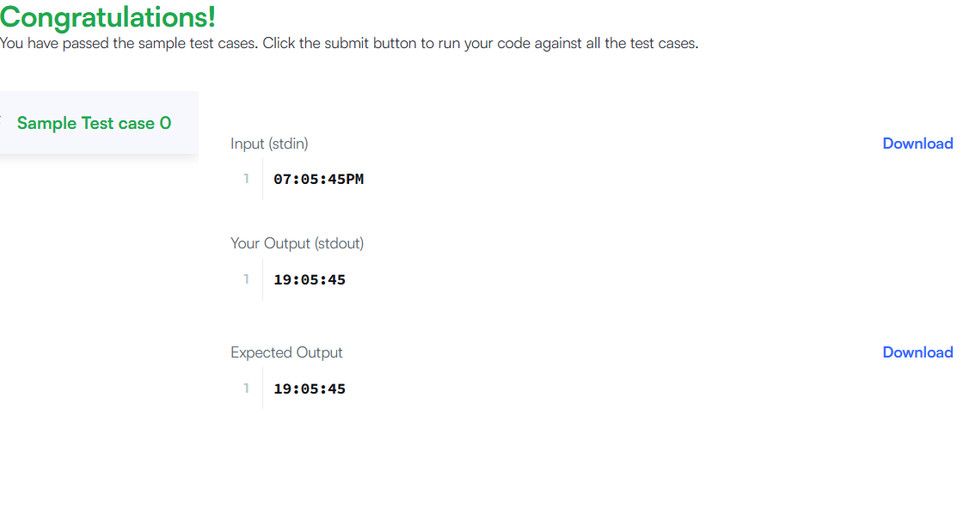
TASK6
Given an integer array nums, move all 0's to the end of it while maintaining the relative order of the non-zero elements.
Note that you must do this in-place without making a copy of the array.

Example 1:
Input: nums = [0,1,0,3,12]
Output: [1,3,12,0,0]
Example 2:
Input: nums = [0]
Output: [0]

PROGRAM:
class Solution {
public void moveZeroes(int[] nums) {
int index = 0;

// Step 1: Move all non-zero elements forward
for (int i = 0; i < nums.length; i++) {
if (nums[i] != 0) {
nums[index] = nums[i];
index++;
}
}

// Step 2: Fill remaining positions with 0
while (index < nums.length) {
nums[index] = 0;
index++;
}
}
}

OUTPUT:
Input
nums =
[0,1,0,3,12]
Output
[1,3,12,0,0]
Expected
[1,3,12,0,0]

TASK 7
Given a square matrix, calculate the absolute difference between the sums of its diagonals.
For example, the square matrix is shown below:
1 2 3
4 5 6
9 8 9
- The left-to-right diagonal = .
- The right-to-left diagonal = .
Their absolute difference is .
Function description
Complete the function with the following parameter:
- : a 2-D array of integers
Return
- : the absolute difference in sums along the diagonals
Input Format
The first line contains a single integer, , the number of rows and columns in the square matrix .
Each of the next lines describes a row, , and consists of space-separated integers .
Constraints

Sample Input
STDIN Function
----- --------
3 arr[][] sizes n = 3, m = 3
11 2 4 arr = [[11, 2, 4], [4, 5, 6], [10, 8, -12]]
4 5 6
10 8 -12
Sample Output
15
Explanation
The primary diagonal is:
11
5
-12
Sum across the primary diagonal: .
The secondary diagonal is:
4
5
10
Sum across the secondary diagonal:
PROGRAM:
import java.util.*;

public class DiagonalDifference {
public static void main(String[] args) {
Scanner sc = new Scanner(System.in);

int n = sc.nextInt();
int[][] arr = new int[n][n];

// Input matrix
for (int i = 0; i < n; i++) {
for (int j = 0; j < n; j++) {
arr[i][j] = sc.nextInt();
}
}

int primarySum = 0;
int secondarySum = 0;

for (int i = 0; i < n; i++) {
primarySum += arr[i][i];
secondarySum += arr[i][n - i - 1];
}

int result = Math.abs(primarySum - secondarySum);
System.out.println(result);
}
}
OUTPUT:
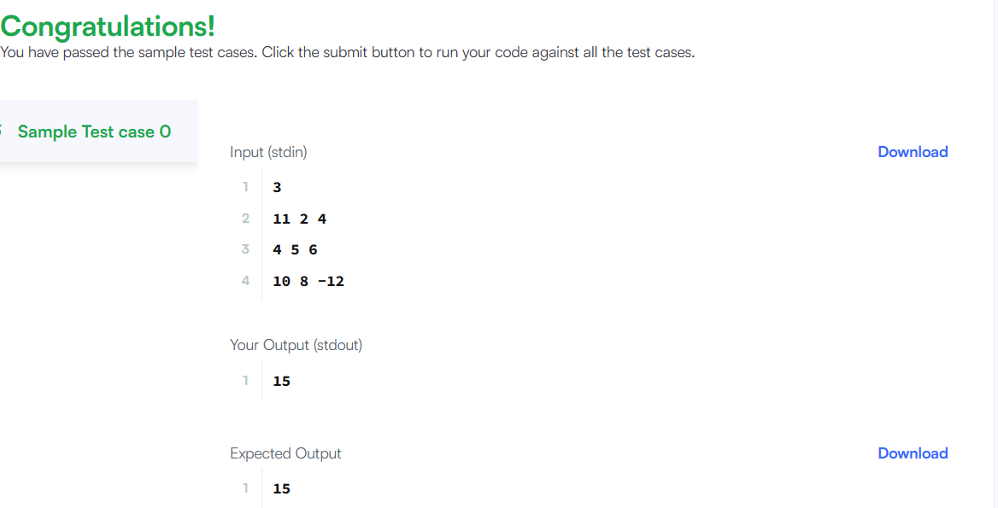
TASK 8
Given a 2D integer array matrix, return the transpose of matrix.
The transpose of a matrix is the matrix flipped over its main diagonal, switching the matrix's row and column indices.
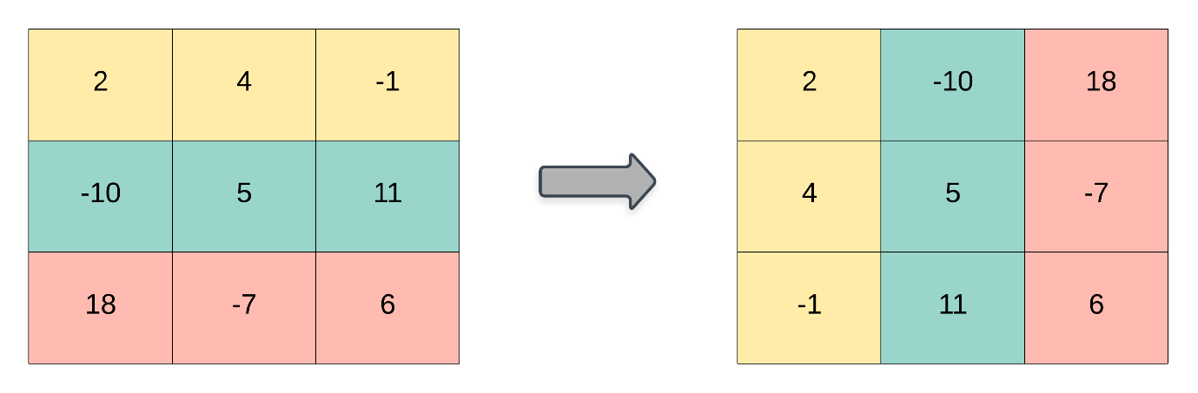

Example 1:
Input: matrix = [[1,2,3],[4,5,6],[7,8,9]]
Output: [[1,4,7],[2,5,8],[3,6,9]]
Example 2:
Input: matrix = [[1,2,3],[4,5,6]]
Output: [[1,4],[2,5],[3,6]]

Constraints:
- m == matrix.length
- n == matrix[i].length
- 1 <= m, n <= 1000
- 1 <= m * n <= 10⁵
- -10⁹ <= matrix[i][j] <= 10⁹
PROGRAM:
import java.util.*;

public class DiagonalDifference {
public static void main(String[] args) {
Scanner sc = new Scanner(System.in);

int n = sc.nextInt();
int[][] arr = new int[n][n];

// Input matrix
for (int i = 0; i < n; i++) {
for (int j = 0; j < n; j++) {
arr[i][j] = sc.nextInt();
}
}

int primarySum = 0;
int secondarySum = 0;

for (int i = 0; i < n; i++) {
primarySum += arr[i][i];
secondarySum += arr[i][n - i - 1];
}

int result = Math.abs(primarySum - secondarySum);
System.out.println(result);
}
}
OUTPUT:
Accepted
Runtime: 0 ms
Case 1
Case 2
Input
matrix =
[[1,2,3],[4,5,6],[7,8,9]]
Output
[[1,4,7],[2,5,8],[3,6,9]]
Expected
[[1,4,7],[2,5,8],[3,6,9]]

TASK 9
Given a m x n matrix mat and an integer k, return a matrix answer where each answer[i][j] is the sum of all elements mat[r][c] for:
- i - k <= r <= i + k,
- j - k <= c <= j + k, and
- (r, c) is a valid position in the matrix.

Example 1:
Input: mat = [[1,2,3],[4,5,6],[7,8,9]], k = 1
Output: [[12,21,16],[27,45,33],[24,39,28]]
Example 2:
Input: mat = [[1,2,3],[4,5,6],[7,8,9]], k = 2
Output: [[45,45,45],[45,45,45],[45,45,45]]

Constraints:
- m == mat.length
- n == mat[i].length
- 1 <= m, n, k <= 100
- 1 <= mat[i][j] <= 100
PROGRAM:
class Solution {
public int[][] matrixBlockSum(int[][] mat, int k) {
int m = mat.length;
int n = mat[0].length;

// Step 1: Build prefix sum matrix
int[][] pre = new int[m + 1][n + 1];

for (int i = 1; i <= m; i++) {
for (int j = 1; j <= n; j++) {
pre[i][j] = mat[i - 1][j - 1]
+ pre[i - 1][j]
+ pre[i][j - 1]
- pre[i - 1][j - 1];
}
}

// Step 2: Compute result
int[][] ans = new int[m][n];

for (int i = 0; i < m; i++) {
for (int j = 0; j < n; j++) {

int r1 = Math.max(0, i - k);
int c1 = Math.max(0, j - k);
int r2 = Math.min(m - 1, i + k);
int c2 = Math.min(n - 1, j + k);

ans[i][j] = pre[r2 + 1][c2 + 1]
- pre[r1][c2 + 1]
- pre[r2 + 1][c1]
+ pre[r1][c1];
}
}

return ans;
}
}
OUPUT:
Accepted
Runtime: 0 ms
Case 1
Case 2
Input
mat =
[[1,2,3],[4,5,6],[7,8,9]]
k =
1
Output
[[12,21,16],[27,45,33],[24,39,28]]
Expected
[[12,21,16],[27,45,33],[24,39,28]]

TASK 10
You are given a 2D matrix of dimension and a positive integer . You have to rotate the matrix times and print the resultant matrix. Rotation should be in anti-clockwise direction.
Rotation of a matrix is represented by the following figure. Note that in one rotation, you have to shift elements by one step only.
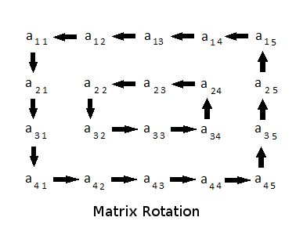
It is guaranteed that the minimum of m and n will be even.
As an example rotate the Start matrix by 2:
Start First Second
1 2 3 4 2 3 4 5 3 4 5 6
12 1 2 5 -> 1 2 3 6 -> 2 3 4 7
11 4 3 6 12 1 4 7 1 2 1 8
10 9 8 7 11 10 9 8 12 11 10 9
Function Description
Complete the matrixRotation function in the editor below.
matrixRotation has the following parameter(s):
- int matrix[m][n]: a 2D array of integers
- int r: the rotation factor
Prints
It should print the resultant 2D integer array and return nothing. Print each row on a separate line as space-separated integers.
Input Format
The first line contains three space separated integers, , , and , the number of rows and columns in , and the required rotation.
The next lines contain space-separated integers representing the elements of a row of .
Constraints

Sample Input
Sample Input #01
STDIN Function
----- --------
4 4 2 rows m = 4, columns n = 4, rotation factor r = 2
1 2 3 4 matrix = [[1, 2, 3, 4], [5, 6, 7, 8], [9, 10, 11, 12], [13, 14, 15, 16]]
5 6 7 8
9 10 11 12
13 14 15 16
Sample Output #01
3 4 8 12
2 11 10 16
1 7 6 15
5 9 13 14
Explanation #01
The matrix is rotated through two rotations.
1 2 3 4 2 3 4 8 3 4 8 12
5 6 7 8 1 7 11 12 2 11 10 16
9 10 11 12 -> 5 6 10 16 -> 1 7 6 15
13 14 15 16 9 13 14 15 5 9 13 14
Sample Input #02
5 4 7
1 2 3 4
7 8 9 10
13 14 15 16
19 20 21 22
25 26 27 28
Sample Output #02
28 27 26 25
22 9 15 19
16 8 21 13
10 14 20 7
4 3 2 1
Explanation 02
The various states through 7 rotations:
1 2 3 4 2 3 4 10 3 4 10 16 4 10 16 22
7 8 9 10 1 9 15 16 2 15 21 22 3 21 20 28
13 14 15 16 -> 7 8 21 22 -> 1 9 20 28 -> 2 15 14 27 ->
19 20 21 22 13 14 20 28 7 8 14 27 1 9 8 26
25 26 27 28 19 25 26 27 13 19 25 26 7 13 19 25

10 16 22 28 16 22 28 27 22 28 27 26 28 27 26 25
4 20 14 27 10 14 8 26 16 8 9 25 22 9 15 19
3 21 8 26 -> 4 20 9 25 -> 10 14 15 19 -> 16 8 21 13
2 15 9 25 3 21 15 19 4 20 21 13 10 14 20 7
1 7 13 19 2 1 7 13 3 2 1 7 4 3 2 1
Sample Input #03
2 2 3
1 1
1 1
Sample Output #03
1 1
1 1
PROGRAM:
import java.util.*;

public class Solution {

public static void matrixRotation(int[][] matrix, int r) {
int m = matrix.length;
int n = matrix[0].length;

int layers = Math.min(m, n) / 2;

for (int layer = 0; layer < layers; layer++) {

List<Integer> list = new ArrayList<>();

// Top row
for (int j = layer; j < n - layer; j++)
list.add(matrix[layer][j]);

// Right column
for (int i = layer + 1; i < m - layer - 1; i++)
list.add(matrix[i][n - layer - 1]);

// Bottom row
for (int j = n - layer - 1; j >= layer; j--)
list.add(matrix[m - layer - 1][j]);

// Left column
for (int i = m - layer - 2; i > layer; i--)
list.add(matrix[i][layer]);

int size = list.size();
int rot = r % size;

// Rotate anti-clockwise
Collections.rotate(list, -rot);

int index = 0;

// Put back

// Top
for (int j = layer; j < n - layer; j++)
matrix[layer][j] = list.get(index++);

// Right
for (int i = layer + 1; i < m - layer - 1; i++)
matrix[i][n - layer - 1] = list.get(index++);

// Bottom
for (int j = n - layer - 1; j >= layer; j--)
matrix[m - layer - 1][j] = list.get(index++);

// Left
for (int i = m - layer - 2; i > layer; i--)
matrix[i][layer] = list.get(index++);
}

// Print result
for (int i = 0; i < m; i++) {
for (int j = 0; j < n; j++) {
System.out.print(matrix[i][j] + " ");
}
System.out.println();
}
}

public static void main(String[] args) {
Scanner sc = new Scanner(System.in);

int m = sc.nextInt();
int n = sc.nextInt();
int r = sc.nextInt();

int[][] matrix = new int[m][n];

for (int i = 0; i < m; i++) {
for (int j = 0; j < n; j++) {
matrix[i][j] = sc.nextInt();
}
}

matrixRotation(matrix, r);
}
}
OUTPUT:
